<https://public.tableau.com/app/profile/salim.malik3338/viz/Project2-ComparisonofRegionBasedonSales_16710233871450/Dashboard1?publish=yes>

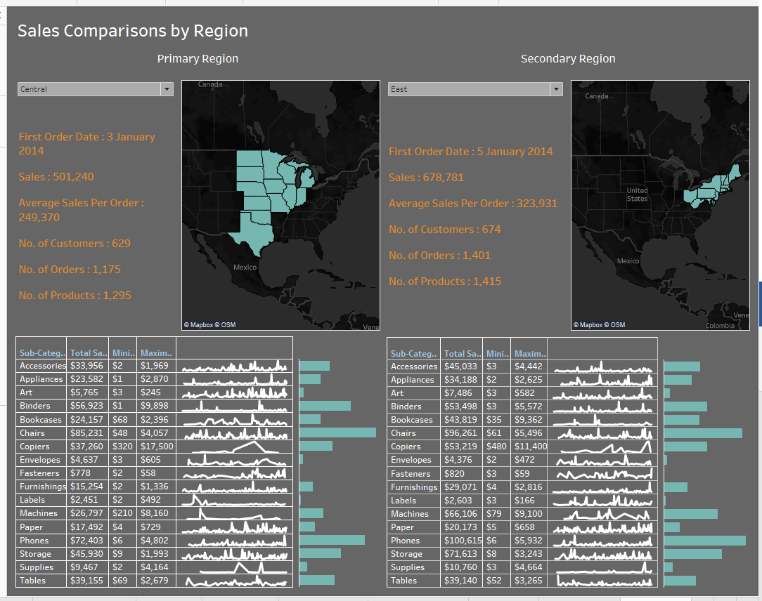

Write Up:

Some observations noted from the study just for reference:

Primary Region: (Central)

First Order Date: 3 January 2014

Sales: 501,240

Average Sales Per Order: 249,370

No. of Customers: 629

No. of Orders: 1,175

No. of Products: 1,295

Secondary Region: (West)

First Order Date: 6 January 2014

Sales: 725,458

Average Sales Per Order: 352,307

No. of Customers: 686

No. of Orders: 1,611

No. of Products: 1,503